Supplementary Material
Tables.
Table S1. Reference subsites (bovine trypsin residues within 4.5 Å of the inhibitor residue at each position).
Subsite | BPTI residue | Trypsin contacts (2PTC) | SFTI-1 residue | Trypsin contacts (1SFI)
S4 | Gly12 | Gln192 | Arg2 | Asn97, Gln175, Gly216, Ser217, Trp215
S3 | Pro13 | Gln192, Gly216, Trp215 | Cys3 | Gln192, Gly216, Trp215
S2 | Cys14 | Gln192, His57, Leu99, Ser195, Ser214, Trp215 | Thr4 | Gln192, His57, Leu99, Ser195, Ser214, Trp215
S1 | Lys15 | Asp189, Asp194, Cys191, Gln192, Gly193, Gly216, Gly219, Gly226, His57, Ser190, Ser195, Ser214, Trp215, Val213 | Lys5 | the same 14 residues
S1′ | Ala16 | Cys42, Gln192, Gly193, His57, Phe41, Ser195 | Ser6 | the same 6 residues
S2′ | Arg17 | Gln192, Gly193, His40, Phe41, Tyr151, Tyr39 | Ile7 | the same 6 residues
S3′ | Ile18 | His57, Phe41, Tyr39 | Pro8 | none

Table S2. Catalytic triad and S1 pocket residues of the ten receptors (AlphaFold models). Residue positions correspond to the model numbering, whereas the bovine trypsin (P00760) column provides the reference numbering. Bold indicates residues that differ from those in bovine trypsin. The S1 pocket comprises the 14 trypsin residues in contact with the P1 residue in structures 2PTC and 1SFI (Table S1). His57 and Ser195 are included in this set but are listed only once, under the catalytic triad. Asp189 is the specificity-determining residue. Distances were measured in the models between the NE2 atom of His and the OG atom of Ser, and between the ND1 atom of His and the nearest carboxylate oxygen atom of Asp102. Data: data-lepidoptera-panel/triad_s1_by_receptor.csv; script: manuscript/make_table_s2.py.

Group | Position | Bovine trypsin | S. frugiperda | S. litura | O. nubilalis | D. saccharalis | C. includens | H. virescens | P. xylostella | A. gemmatalis | M.  sexta | B. mori
Catalytic triad | His57 | H57 | H69 | H69 | H69 | H69 | H69 | H68 | H70 | H71 | H70 | H70
 | Asp102 | D102 | D114 | D114 | D114 | D114 | D114 | D113 | D116 | D116 | D115 | D115
 | Ser195 | S195 | S220 | S211 | S213 | S213 | S212 | S219 | S211 | S217 | S213 | S212
S1 pocket | Asp189 | D189 | D214 | D205 | D207 | D207 | D206 | D213 | D205 | D211 | D207 | D206
 | Ser190 | S190 | A215 | Q206 | Q208 | Q208 | Q207 | A214 | A206 | Q212 | Q208 | S207
 | Cys191 | C191 | C216 | C207 | C209 | C209 | C208 | C215 | C207 | C213 | C209 | C208
 | Gln192 | Q192 | Q217 | Q208 | Q210 | Q210 | Q209 | Q216 | Q208 | Q214 | Q210 | T209
 | Gly193 | G193 | G218 | G209 | G211 | G211 | G210 | G217 | G209 | G215 | G211 | G210
 | Asp194 | D194 | D219 | D210 | D212 | D212 | D211 | D218 | D210 | D216 | D212 | D211
 | Val213 | V213 | T235 | C225 | C227 | C227 | C226 | V234 | V225 | C231 | C227 | S226
 | Ser214 | S214 | S236 | S226 | S228 | S228 | S227 | S235 | S226 | S232 | S228 | S227
 | Trp215 | W215 | W237 | F227 | W229 | W229 | W228 | W236 | W227 | F233 | W229 | F228
 | Gly216 | G216 | G238 | G228 | G230 | G230 | G229 | G237 | G228 | G234 | G230 | G229
 | Gly219 | G219 | E240 | G230 | G232 | G232 | Q231 | Q239 | G230 | G236 | E232 | N231
 | Gly226 | G226 | G248 | G238 | G240 | G240 | G239 | G247 | G238 | G244 | G240 | G239
Geometry | His NE2…Ser OG (Å) | – | 3.12 | 3.00 | 2.95 | 2.92 | 3.00 | 3.13 | 2.98 | 2.95 | 2.95 | 3.00
 | His ND1…Asp102 OD (Å) | – | 2.71 | 2.72 | 2.73 | 2.75 | 2.73 | 2.72 | 2.75 | 2.71 | 2.70 | 2.74

Figures.
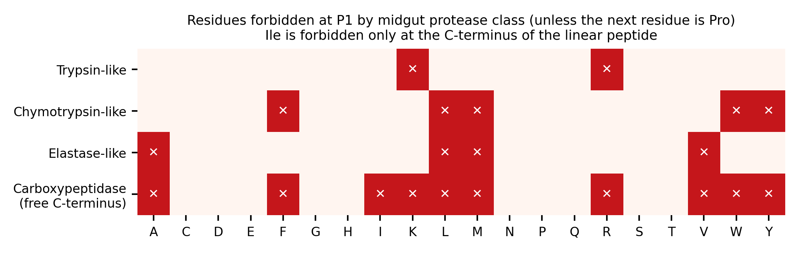
Figure S1. Amino acid residues forbidden at the P1 position according to midgut protease class under the strict non-cleavability criterion. Restrictions are waived when the following residue is proline (Pro), whereas isoleucine (Ile) is forbidden only at the free C-terminus of linear peptides.
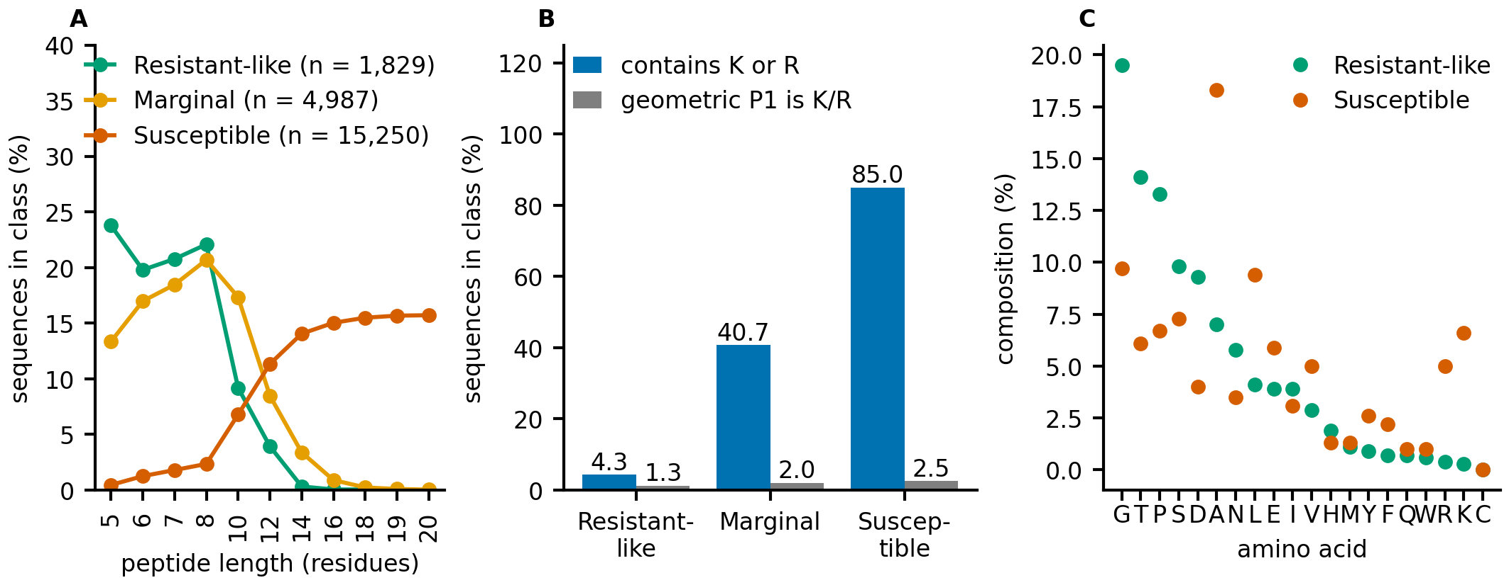
Figure S2. Properties of the 22,066 designed sequences classified by cleavage-motif score screening. (A) Peptide length distribution. (B) Percentage of sequences containing lysine (K) or arginine (R), and percentage with K or R at the geometric P1 proxy position. (C) Amino acid composition of the resistant and susceptible classes.
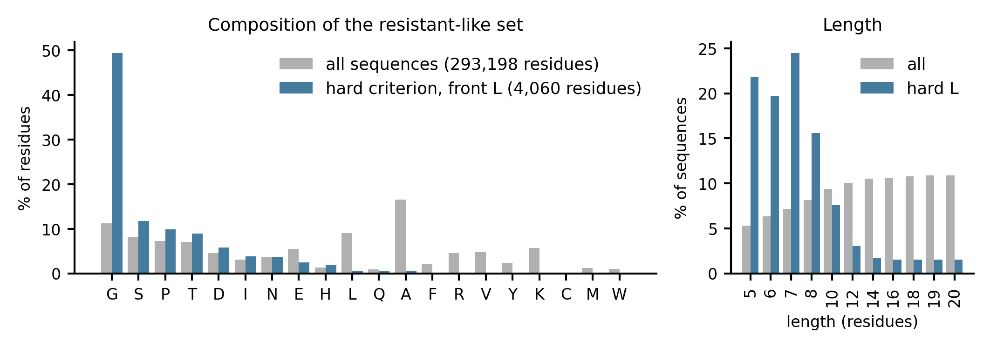
Figure S3. Composition of the sequence set retained by the strict non-cleavability criterion: amino acid composition of all sequences and the 527 linear peptides, and their respective peptide length distributions.
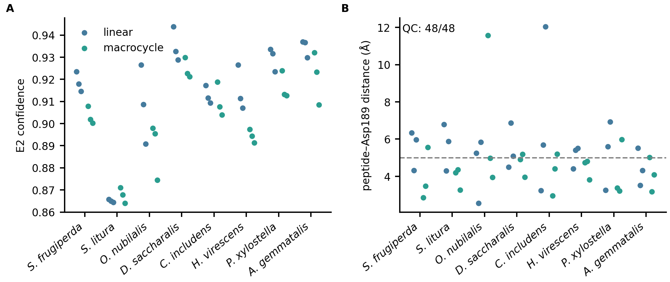
Figure S4. Structural properties of the 48 final peptide candidates. (A) E2 confidence scores. (B) Minimum distance between the peptide and the carboxylate group of Asp189 in the initial structure (dashed line: 5 Å).
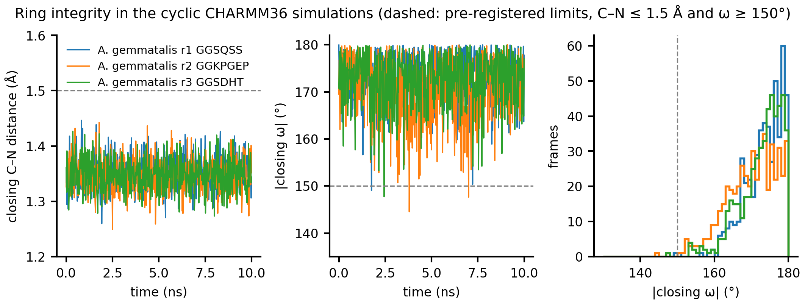
Figure S5. Integrity of the ring-closing bond in molecular dynamics simulations of the A. gemmatalis M-track candidates (10 ns, pH 10.0): ring-closing C–N distance, absolute value of the ring-closing ω dihedral angle over time, and ω angle distribution. Dashed lines indicate the predefined thresholds (C–N ≤ 1.5 Å and ω ≥ 150°).
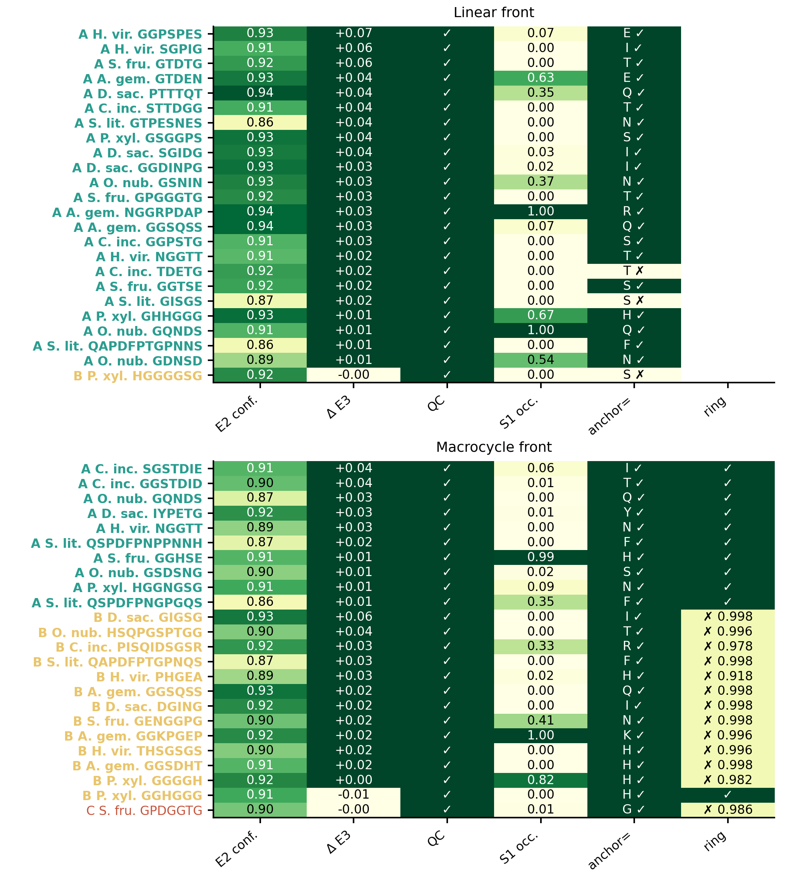
Figure S6. Evidence matrix and tier assignments (A, B, C) for the 48 final peptide candidates, ranked within each tier by paired difference, Boltz-2 confidence, and S1 occupancy (S1 occupancy does not determine tier assignment).
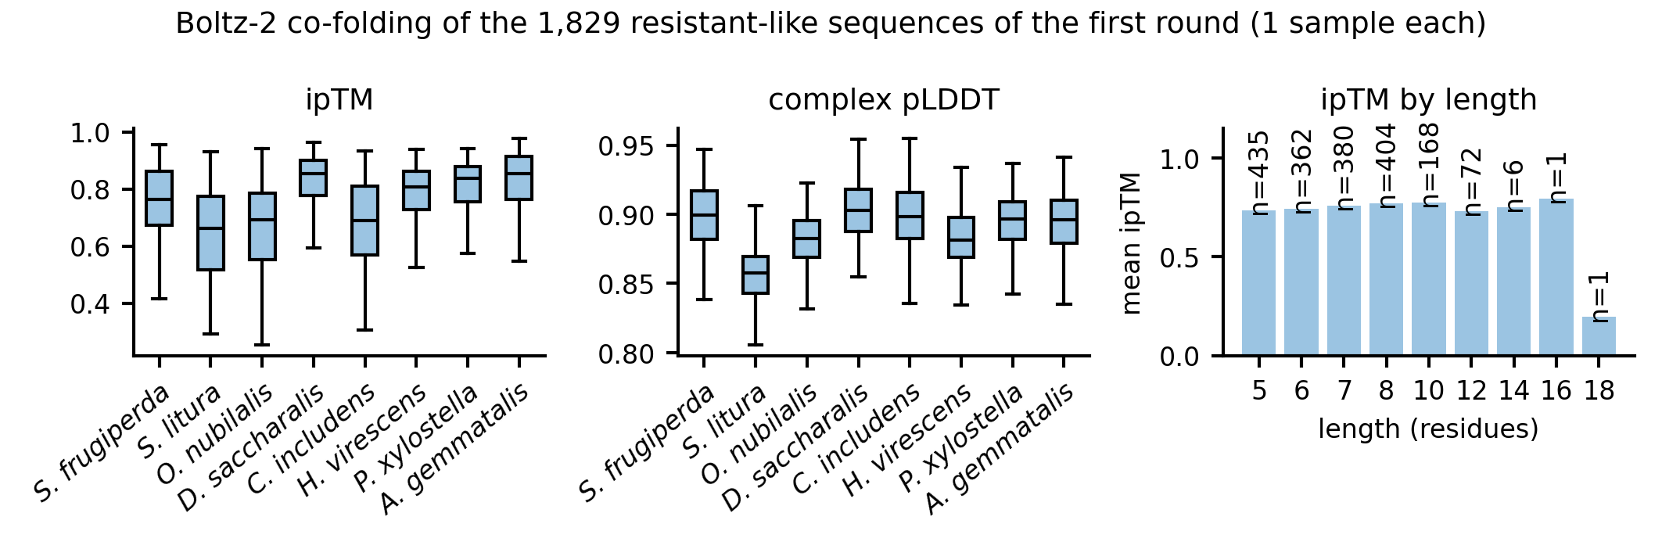
Figure S7. Boltz-2 co-folding predictions for the 1,829 sequences classified as resistant from the first screening round: complex ipTM and pLDDT scores by species, and mean ipTM as a function of peptide length.
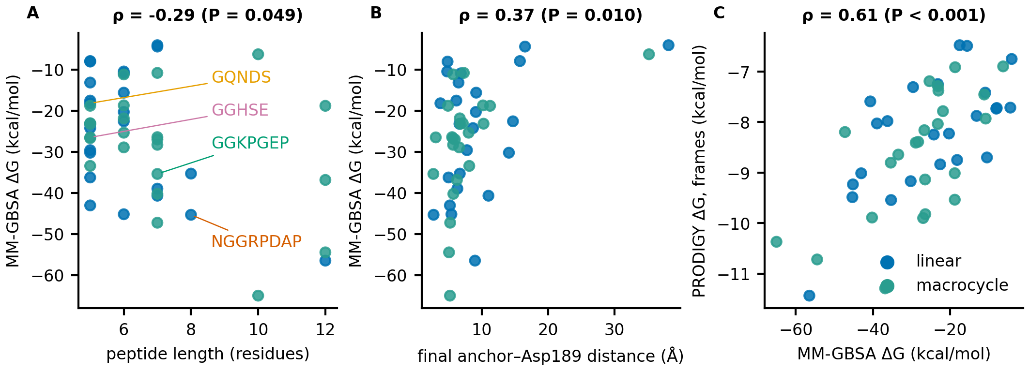
Figure S8. MM-GBSA and PRODIGY analyses of the trajectories from the 48 simulations at pH 10.0 (second half of the trajectories; ΔG values without entropic contributions). (A) MM-GBSA ΔG versus peptide length. (B) MM-GBSA ΔG versus final anchor–Asp189 distance. (C) PRODIGY ΔG calculated from 30 frames versus MM-GBSA ΔG. ρ denotes Spearman's rank correlation coefficient.
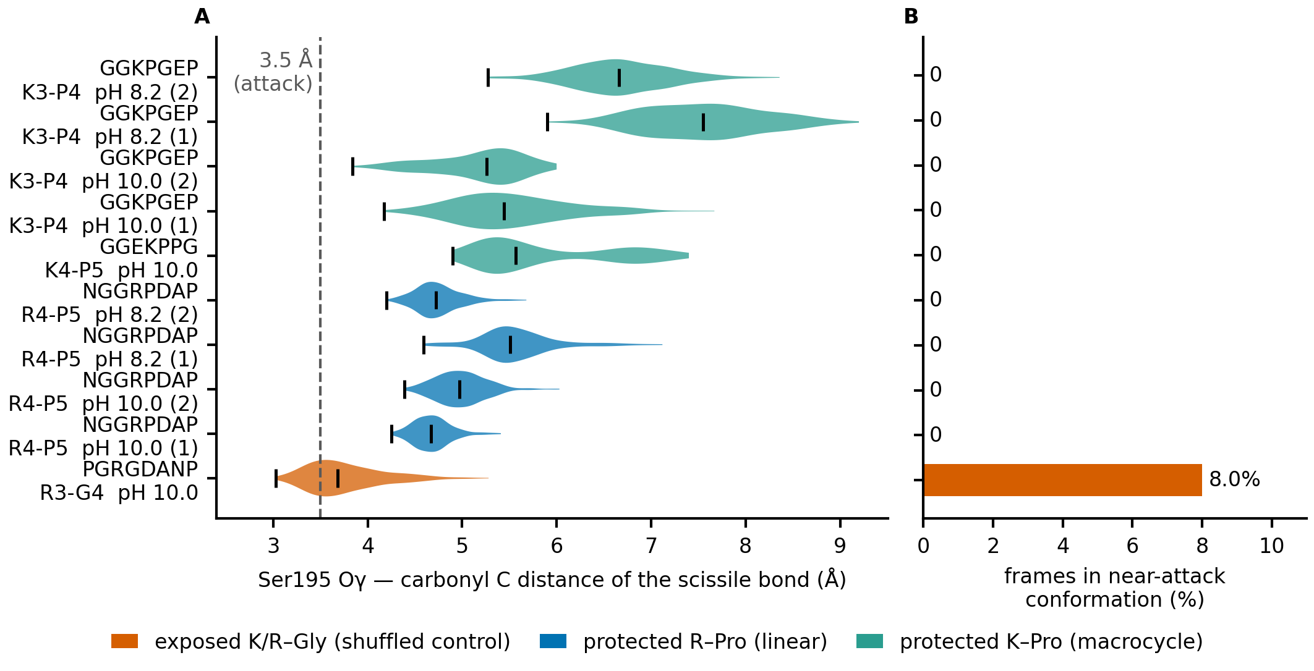
Figure S9. Attack geometry of the scissile bond: proline-protected site versus exposed site. PGRGDANP, the scrambled control of NGGRPDAP, has the same amino acid composition and was simulated with the same receptor and protocol (10 ns, CHARMM36, pH 10.0), with its Arg3 in S1 at the same depth (2.73 Å; occupancy 1.00) but followed by glycine instead of proline. (A) Distribution, over the second half of each run, of the distance from the Ser195 Oγ atom to the carbonyl carbon of the bond following the basic residue (violin: distribution; black bar: median; tick on the left: minimum; dashed line: the 3.5 Å of the near-attack criterion). (B) Fraction of frames in the second half in a near-attack conformation. Orange: exposed site (K/R–Gly); blue: proline-protected site of the linear candidate; teal: proline-protected site of an M-track candidate.

